 Cub Newsletter
February 2023
Main Office 324-2800 Attendance Line 324-2802
Office hours 7:30 a.m.- 4:00 p.m.
School day hours 8:05 a.m.-2:50 p.m.
Library hours 7:50 a.m. - 3:20 p.m
Transportation 324-2100

From the Principal, Kathleen Prody


We have been busy here at CRA with the onset of the new year and we are already approaching the midterm of the 3rd quarter. Parent/teacher conferences are on February 15 and 16, so if you have not signed up with your student’s teacher(s), please make an appointment. Your child’s advisor will reach out to you to set up conferences; however, if you would like to meet with one or more of your child’s content area teachers, please reach out to them for an appointment. We look forward to seeing you!

Registration for 8th grade students going to CHS begins on Monday, March 13th. The CHS counselors will come to CRA to talk about class offerings and to hand out registration forms. On Wednesday, March 15, CRA 8th graders will take a tour of CHS and on Friday, March 17th registration for CHS class is due to the 8th grade counselor, Mrs. Goyette. This is an important transition and CHS and CRA counselors will be available to help in class selections.



Happy Valentine’s Day! This is a fun holiday for many but lonely for others. Please do not send flowers and/or balloons to your students during the school day. We appreciate that you want to brighten your child’s day, but our classrooms do not have the space and the gifts cause significant disruption to instruction. The office has no space to store flowers/balloons until the end of the day so please surprise your students at home rather than at school. Thank you for your help in keeping instruction on track. If your student brings in cards or favors for friends, please have them be mindful about not leaving classmates out.


Mr. Cleary’s orchestra is hosting the annual “Informances” on February 23 and 24. Parents and community are invited to attend orchestra class for a daytime concert. Contact your student to find out during which period they are performing and stop in for a musical respite during your day.

Attendance Office phone number 324-2802

** Please let us know if any phone numbers, addresses, or e-mails have changed so we can keep in contact with you!

**Also – if you need to pick your child up during the school day, please send a note w them or call us ahead of time (preferably at least an hour). Picking up during lunchtime is especially difficult to find students.

Important Dates

February 6th 8th Grade Concert Band-CHS
February 15th & 16th Parent/Teachers Conferences
February 20th No School-President’s Day
February 23rd Choir Concerts-HMS
February 23rd/24th Orchestra Informances
March 14th Eighth Grade Orchestra Festival-HMS
March 20th Seventh Grade Band Festival – Civic Center
March 21st Eighth Grade Band Festival - Civic Center
March 24th End of 3rd Quarter
March 27th- March 31st No School – Spring Break
April 3rd – 4th Quarter Begins

YEARBOOKS ARE ON SALE!

CRA 2023 Yearbooks are on sale now!

Pick up an order form at the front office or order online at https://yearbookforever.com/

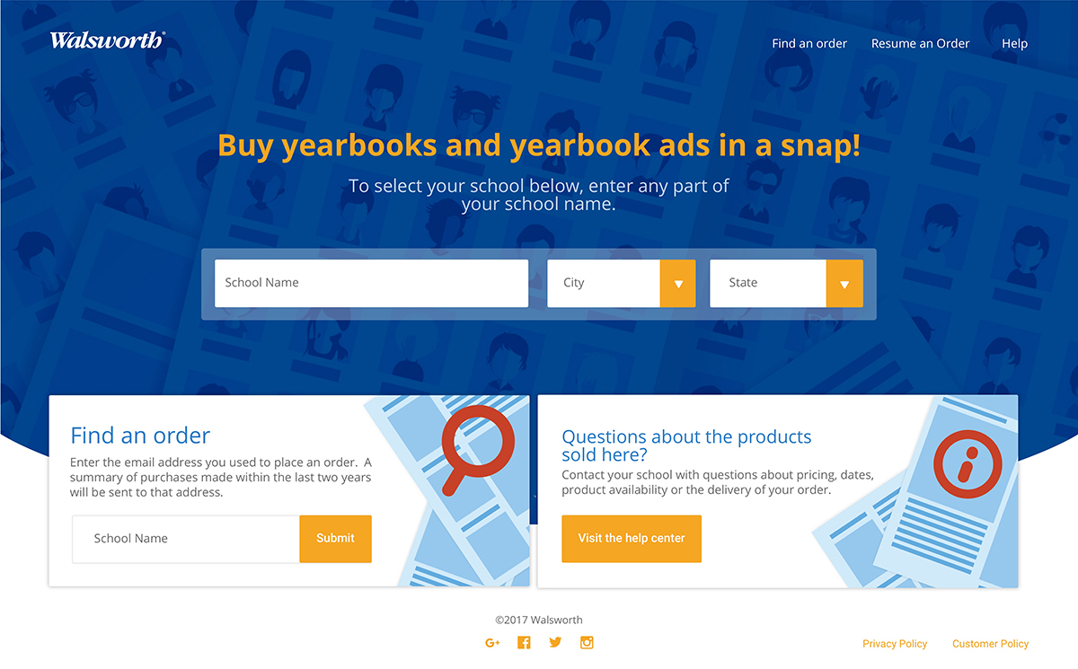 | Find School  There's a great new way to show our school spirit! On Walsworth Yearbook's new site, you can buy this year's yearbook or a yearbook ad. I showed my school spirit, and you should too. Just go to the website and have fun!  yearbookforever.com

Be a Yearbook Angel!!

To Sponsor a Yearbook:
Go to yearbookforever.com and search for our school name.
Order a yearbook with YEARBOOK as the student first name and ANGEL as the last name. Select STAFF as the grade.
First Name: YEARBOOK
Last Name: ANGEL
Grade: STAFF

Our school staff will make sure a deserving student receives a yearbook.
YEARBOOKFOREVER.COM



Middle School Activities

The C.R. Anderson Sports Program is to provide equal and safe opportunities for all students to participate. Our focus is to foster competition, sportsmanship, teamwork, and individual improvement.

Registration forms will be available at the main office, prior to the start of that particular sport. Fees ($40 per activity) must be paid at the time of registration.

Volleyball 6th & 7th Grades Starts March 14 – April 27

Track Starts May 2 – June 1

After-School Kids Academic Assistance Program

We are currently accepting applications for the after-school study program. Applications are available in the main office. Return completed applications to the main office.
Mrs. Bisom will contact you prior to your child starting.

We will meet Tuesday and Thursday from 3:00 to 4:00.

Students in this program receive assistance with their homework from teachers. The participants are expected to follow all school rules and come prepared to work during the study time. Attendance is expected unless there has been an excused absence for the school day. Enrollment is limited and a waiting list is kept for any overflow.

Freshman Registration for 2023-2024

March 13th - Registration Materials Dropped Off
March 15th – CHS Tour – 8th graders to visit CHS
March 15th – Parent Night at CHS – 6:30 pm (auditorium)

Capital High School will be hosting an informational meeting in the CHS auditorium on Wednesday, March 15th at 6:30 pm concerning freshman scheduling.
This meeting will cover registration for all new 9th grade students who will be attending Capital High School in the fall of 2023. The format of the meeting will be as follows:
- Department presentations regarding the freshman classes and how students will be selected for such classes as Honors Earth Science, Honors Math, General Earth Science, Applied English, and JMG
- Registration Process
- College Entrance Requirements
The various Department Heads will answer questions that are related to the current Registration Guide and course selection for the next year.
All Parents Are Urged to Attend with Your Student!

After-School Kids Academic Assistance Program

We are currently accepting applications for the after-school study program. Please fill out application below and email to ksprott@helenaschools.org or pick one up at the office and drop off.

We will meet Tuesday and Thursday from 3:00 to 4:00.

Students in this program receive assistance with their homework from teachers. The participants are expected to follow all school rules and come prepared to work during the study time. Attendance is expected unless there has been an excused absence for the school day. Enrollment is limited and a waiting list is kept for any overflow. This year, there are no buses available, so all parents must pick up students at 4 pm in front of CRA.

We will start Dec. 1st and run thru May 12th, 2023. If you have any questions, please call our After School Coordinator, Ms. Sprott, at 324-2784.

Here is the link:

2022 After school signup for parents.pdf

CRA Needs Mice!


Computer mice, that is! 😊

If you have any mice that are no longer being used, would you please consider donating them to CRA? We have distributed over 400 mice to students whose Chromebook trackpads have quit working and we are in dire need of more.

You may also want to consider purchasing a mouse for your child if they don’t already have one. If you do purchase a mouse, and your child has been using one from CR Anderson, please return it to the library as another student can put it to use.

*** Chromebook Accidental Damage or Loss Protection Plan ***

Reminder- If you have not filled out a technology use agreement and paid for the protection plan for your child, you might want to consider doing so and opting into the "Accidental Damage and Loss Protection Plan." The plan costs $15 dollars per year and can be a BIG savings to families.

The cost to replace the screen is $100, trackpad - $60, the outer casing- $150, and the entire computer costs between $229-$289 depending on the model year. The protection plan covers all accidental damage and loss. We issue a new computer to your child with no fee to replace any broken parts.

If you are interested in opting into the Accidental Damage or Loss Protection Plan. Have your child stop by the office or library and pick up a form. Fill it out and return it with the $15 fee to the main office.

From the Health Room…

Attention Parents/Guardians of 6th Graders:
A Tdap (tetanus, diphtheria, and pertussis) vaccine is required before your student starts 7th grade. Get this done as soon as possible so the start of their next school year won't be delayed. Bring proof of your vaccine to the school, or you can have it faxed to 406-324-2801.

Also, per Helena Public School Policy:

For the safety of our students: Please remember that students are not allowed to self-carry Over the Counter or non-emergency prescription medications at school. They tend to want to share their meds with other students when they think it may help. Students do not always know the correct dose they should be taking (or giving to another student), the length of time between doses and whether someone else has an allergy to that medication.

For more information, see the CR Anderson Middle School Handbook starting on page 32. https://helenaschools.org/wp-content/uploads/2022/09/CRA-Handbook-2022-2023.pdf

If your student needs medication during the school day, whether it be a routine medication or as needed (other than emergency medications such as an inhaler), the medication needs to be left in the health room. Please call us to discuss how to have your student's med available during the school day.

Thank you!

Shelly Maag, RN
School Nurse
C.R. Anderson Middle School
Ph# 324-2766

Hot Chocolate for cancer!
The 6th grade Gold Team will be selling hot chocolate from February 6th-23rd.

Where: Mrs. Richards room, #225

When: During advisor, lunch, and after school
.
Cost: $1 per cup and $.50 cents for toppings


Donations welcome! $ or supplies would be greatly appreciated.

Proceeds go to support cancer patients.

Talent Search Students on the Move

6th and 7th grade Talent Search Students will be taking a trip on February 22nd to see Carroll College, Helena College,
and get introduced on the floor of the Legislature.
Applications need to be into Mrs. Goyette by February 10th.
For more info on Talent Search, contact Mrs. Goyette @ 324-2763.





Ironhorse Youth Music is just a month into their spring semester, and students are making tremendous progress already! Our diverse ensembles welcome students of all ages and ability levels who want to explore challenging symphonic and choral literature with their peers. Ensembles meet on Thursdays, but we also offer a lesson program for students interested in private instruction.

If you would like to learn more about our organization, or want an enrollment brochure, please visit our website (https://ironhorsemusic.org/). We welcome strings, brass, woodwind, and percussion players along with vocalists. Talk with your music teacher or contact Mr. Cleary (kcleary@ironhorsemusic.org) if you are interested in joining an Ironhorse program!

New York City 2024

The next music and art tour to New York (led by Mr. Cleary and Mrs. Shockley) will happen over spring break 2024, and all middle and high school students are welcome to join the fun. While 2024 may seem a long way off, planning early makes it easier to save the money needed for such an exciting experience.

Mr. Cleary and Mrs. Shockley have been working with EF Explore America to craft an exciting and engaging tour for students and family members alike. Anyone interested in being a part of the 2024 tour may contact Mr. Cleary at kcleary@helenaschools.org or Mrs. Shockley at rshockley@helenaschools.org. You can learn more or enroll at https://www.efexploreamerica.com/2574971WR.

Everyone is also invited to our next enrollment meeting on Wednesday, March 22 at 6:00 pm. Because this is a general information meeting, it will be held online using Teams. If you would like the link to attend, or if you just want to get on our email list, please visit https://short.cleary.xyz/nyc24rsvp for additional information.

We hope you will consider being a part of this travel adventure so we can all experience the majesty of New York!


Last Chance Music Camps 2023!

The days are finally getting a little longer, and that means it is time to think about all the sunlit activities that summer will bring. Ironhorse Youth Music is thrilled to present Last Chance Lesson Camps and Last Chance Music Camp as one of those exciting activities! Musicians from orchestra, band, or choir are invited to join the excitement of Helena’s own summer music day camp once again this year.

Please contact Mr. Cleary (kcleary@ironhorsemusic.org) if you have questions, check out the camp webpage (http://lastchancemusic.org), or encourage your child to pick up a brochure from any of the music teachers at CRA. We continue to explore new opportunities to provide every student with a fantastic summer music experience; we look forward to working with your child as part of the Last Chance Music Camp!

